Serial Command Interface

Introduction
- Open the included code file 'SerialCommunications.ino'.
This sketch is designed to listen to any messages written to the serial line from the Arduino Serial Monitor. If that message is not a special, predesignated command, the message is simply printed back out. If the message is a predesignated command, some special code is executed instead. In the current form, if you write the message 'Marco' it replies back 'Polo'.
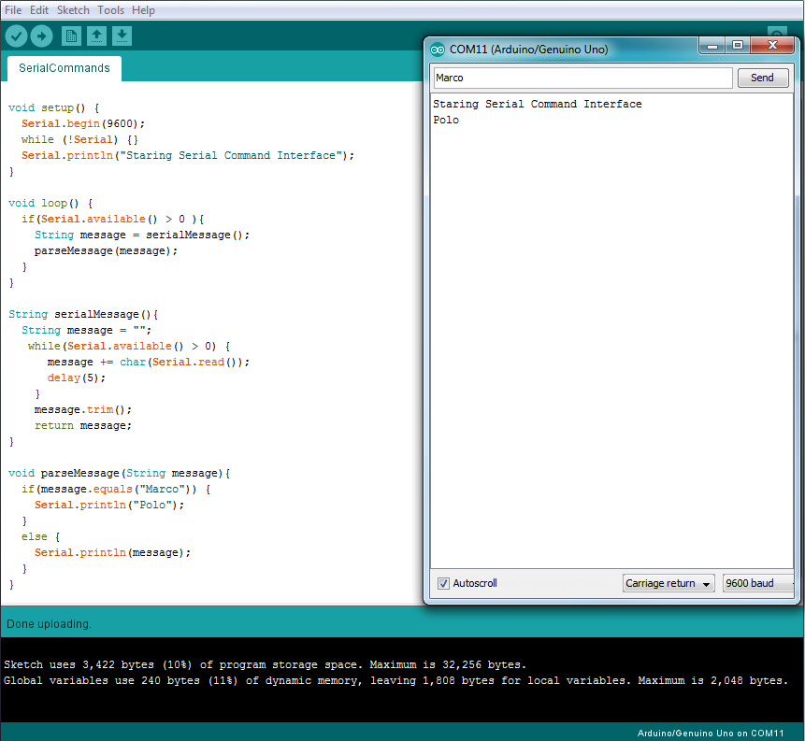
Code Walkthrough

void setup() {
Serial.begin(9600);
while (!Serial) {}
Serial.println("Staring Serial Command Interface");
}
The setup function starts by initializaing a Serial connection at 9600 baud. Next, it waits until the Serial port is ready. Finally, it prints a message to be displayed by the Serial Monitor showing the device has started. This is almost identical to the bevahior of the Repeater from 1.4.
void loop() {
if(Serial.available() > 0 ){
String message = serialMessage();
parseMessage(message);
}
}
The loop function continually checks the serial buffer using Serial.available() to see how many characters are in the buffer. If that number is more than zero, it calls the serialMessage() function and assigns the string it returns to a variable called message. It passes the message along to a function called parseMessage.
void parseMessage(String message){
if(message.equals("Marco")) {
Serial.println("Polo");
}
else {
Serial.println(message);
}
}
This function looks at the messsage we pass in (which again is from the serial buffer) and checks to see if it matches the string 'Marco'. If it does, we print the string 'Polo.' If it does not, we simply echo back the original string.
Programming Challenge
- Using another if statement, extend the parseMessage function to return the string "Pong" if you the message is "Ping".

